**Creating Amazon EventBridge Schedules**

1. Sign into the **AWS Management Console**, open the **EventBridge Scheduler** section of the **EventBridge console** or click [here](https://us-west-2.console.aws.amazon.com/scheduler/home?region=us-west-2#home).
2. On the **Schedules** page, scroll down and choose **Create schedule** button.
3. On the **Specify schedule detail** page, in the **Schedule name and description section** do the following:
   1. For **Schedule name**, enter a name **EC2StartEventSchedule** for your schedule.
   2. For **Description - optional**, enter a description for your schedule.

For example, **A scheduled start event to trigger a Lambda function for initiating the EC2 instance launch.**

* 1. A screenshot of a computer program

     Description automatically generatedFor **Schedule group**, choose **default** or create a **new schedule group.**

1. To create a **new schedule group**, choose the **create your own schedule** link in the description. Under **Schedule group** detail, do these:
2. For **name**, write **MyEC2_STARTandSTOP_ScheduleGroup**.
3. You can also give a tag (key-value) for the resource management.
4. Choose **Create schedule** **group** button and you’re done.
5. In the **Schedule pattern** section, do the following:
   * 1. For **Occurrence**, choose **Recurring schedule** (This schedule is going to run on and on every week, every month, and every year).
     2. For **Schedule type**, choose **Cron-based schedule** (This schedule will run at specific time in the morning and evening).
     3. For **Cron expression**,

|  |  |  |  |  |  |
| --- | --- | --- | --- | --- | --- |
| 30 | 8 | ? | * | 2-6 | * |

Minutes Hours Day of month Month Day of the week Year

* + 1. To learn more about utilizing **cron expressions**, please refer [**here**](https://docs.aws.amazon.com/eventbridge/latest/userguide/eb-cron-expressions.html).
    2. In short, the fields in a cron expression are typically as follows:
       1. Minute (**0-59**)
       2. Hour (**0-23**)
       3. Day of the month (**1-31**)
       4. Month (**1-12** or **JAN-DEC**)
       5. Day of the week (**0-6** or **SUN-SAT**)
       6. Year (optional)
    3. 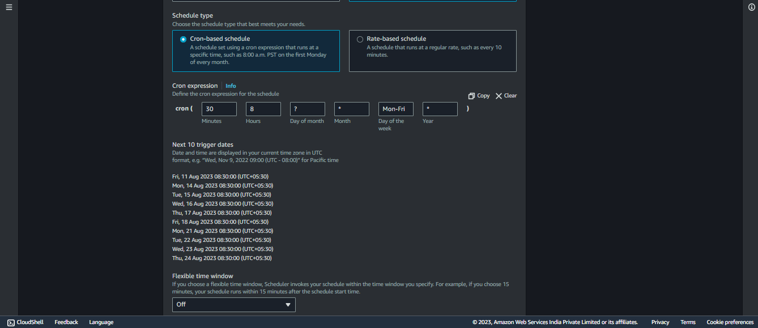To verify the accuracy of the cron expressions you provide, check the next 10 trigger dates.

1. For **Flexible time window**, choose **Off** to turn off the option.
2. In the **Timeframe** section, specify a **Timezone**, and optionally set a start date and time, and an end date and time for the schedule.

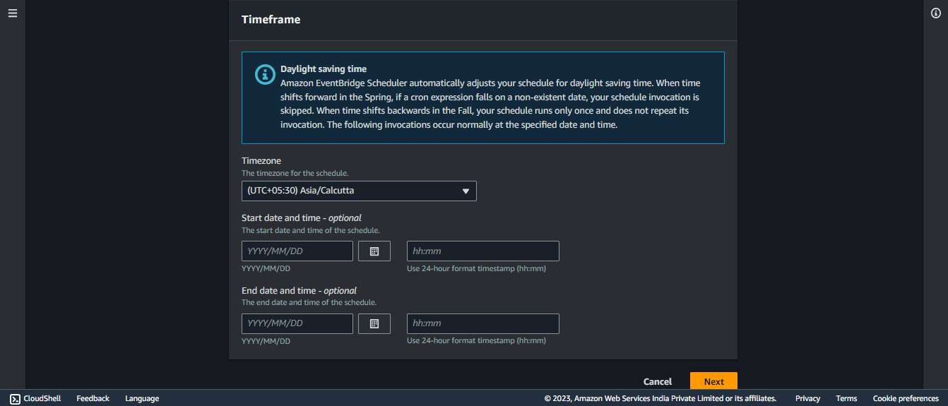**NOTE:** A recurring schedule without a start date will begin as soon as it is created and available and a recurring schedule without an end date will continue to invoke its target indefinitely.

1. Choose **Next**.
2. On the **Select target - *optional*** page, do the following:
   * 1. 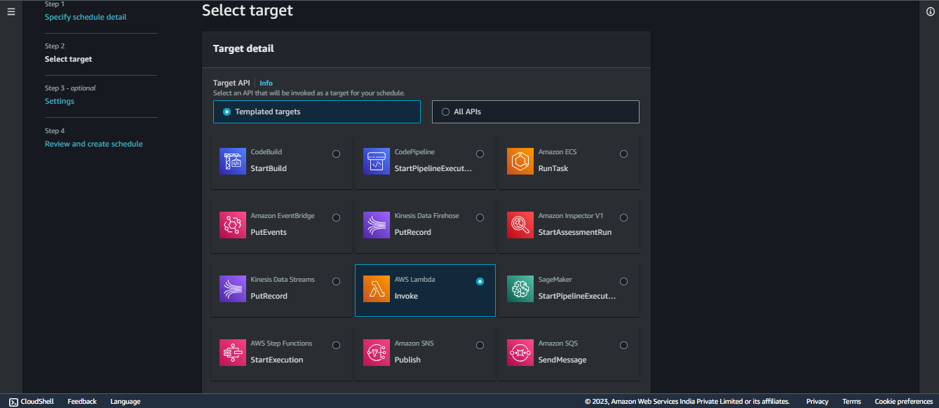Under **Target API**, select **Templated targets** and choose **AWS Lambda Invoke** templated target.
     2. On the **Invoke** section, for **Lambda function**, choose the **Lambda function** that we have made in beforehand from the drop-down list.
     3. For the **Payload**, provide **{“action”: “start”}**.The **Payload** refers to the data that you want **EventBridge Scheduler** to deliver to the **target**, such as a **Lambda function**, when the scheduled event is **triggered**.
     4. 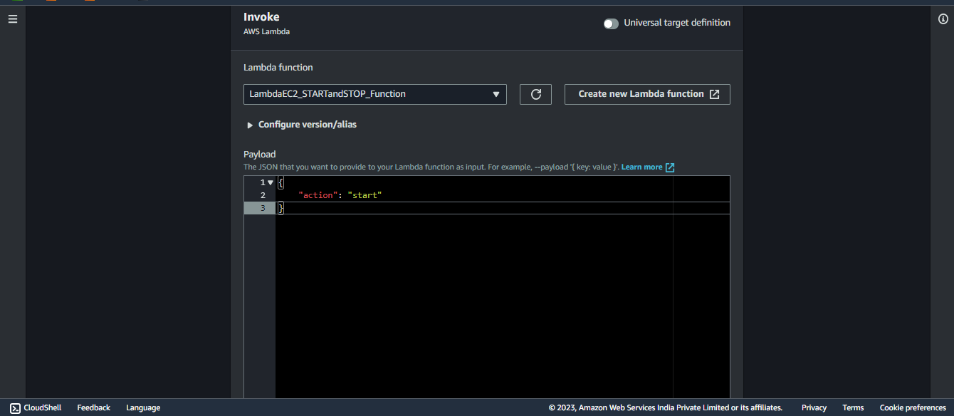**For this example**, the message being sent is in **JSON** format and contains an **"action"** field with the value **"start"** which allows the **EventBridge Scheduler** to **provides instructions or information** to the **target** (**Lambda function**) indicating that it should initiate a "**start**" action.
3. Choose **Next**, then on the **Settings - optional** page, do the following:
4. In the **Schedule state** section, for **Enable schedule**, toggle feature on or off using the switch. The **EventBridge Scheduler** activates your schedule by default, which is the required behaviour.
5. In the **Action after schedule completion** section, choose **NONE**, as we do not want EventBridge Scheduler to take any action after the schedule completes.
6. If you choose **DELETE**, EventBridge Scheduler will automatically delete the schedule after it has completed its last invocation and has no future target invocations planned.
7. For **Maximum age of event - *optional***, enter the maximum hour(s) and min(s) i.e., **24 into hours** and **0 into minutes** so that **EventBridge Scheduler** must keep an unprocessed event for 24 hours.
8. For **Maximum retries**, enter the maximum number of times i.e., **185** times so that EventBridge Scheduler retries the schedule if the target returns an error for 185 times.
9. For **Dead-letter queue (DLQ)**, choose **None** as we don't want to configure a DLQ now.
10. Scroll down to **Permissions** and choose **Use existing role**. From the drop-down of **Select an existing role**, select the **IAM role** you made.
11. Choose **Next**.
12. In the **Review and create schedule** page, review the details of your schedule. In each section, you can choose **Edit** to go back to that step and edit its details.
13. Choose **Create schedule** to finish creating your new schedule.
14. You can view a list of your new and existing schedules on the **Schedules** page. Under the Status column, verify that your new schedule is Enabled.
15. To verify that your schedule invokes the Amazon Lambda target and starts the EC2 instance, check the status the EC2 around set trigger time.
16. You can also check CloudWatch logs for more information.

**“Voila, you're all set! Now, lean back and witness the enchantment unfold when the trigger time arrives. Get ready to experience the magic of automation in action. Your scheduled events will seamlessly orchestrate processes, making your workflows smoother and more efficient. Enjoy the power of AWS EventBridge Scheduler at work!”**